DELHI PUBLIC SCHOOL, SRINAGAR.
CLASS: III ENVIRONMENTAL SCIENCE
WORKSHEET-REVISION 2
Q1 Label different parts of the plant

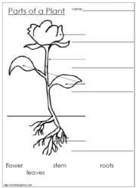

Q2: Fill in the blanks
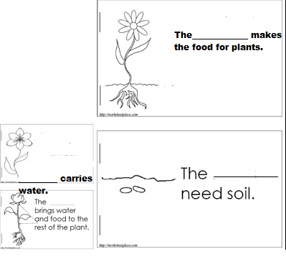
Q3: Write five uses of plants
- ____________________________________________________________
- ____________________________________________________________
- ____________________________________________________________
- ____________________________________________________________
- ____________________________________________________________

DELHI PUBLIC SCHOOL,SRINAGAR.
CLASS: IV ENVIRONMENTAL SCIENCE
WORKSHEET-REVISION 2

Q1: Match the following:
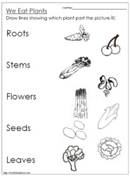

Q2: Make the proper words and encircle them
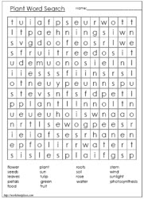
Q3: Give one word
- The process by which the plants make their own food______________
- The green coloured pigment present in the leaves _________________
- Tiny pores present on the lower side of the leaf that help the plant to breathe _______________
Q4:
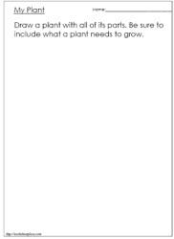

DELHI PUBLIC SCHOOL,SRINAGAR.
CLASS: V ENVIRONMENTAL SCIENCE
WORKSHEET-REVISION 2
Q1 Fill in the blanks

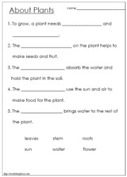

Q2: Give reasons
- Why the leaves of cactus plant are reduced to spines?
________________________________________________________________________________________________________________________________________________________________________________________________________________________________________________________________________________________________________________________________
b) Why the leaves are called the food factory?
________________________________________________________________________________________________________________________________________________________________________________________________________________________________________________________________________________________________________________________________
Q3: Difference between
- Photosynthesis and Transpiration
________________________________________________________________________________________________________________________________________________________________________________________________________________________________________________________________________________________________________________________________

Q4: Draw the following
