 | DELHI PUBLIC SCHOOL,SRINAGAR
 | Summer Assignment
 | Class :U.K.G | Sub: Ev.sc | Grade:
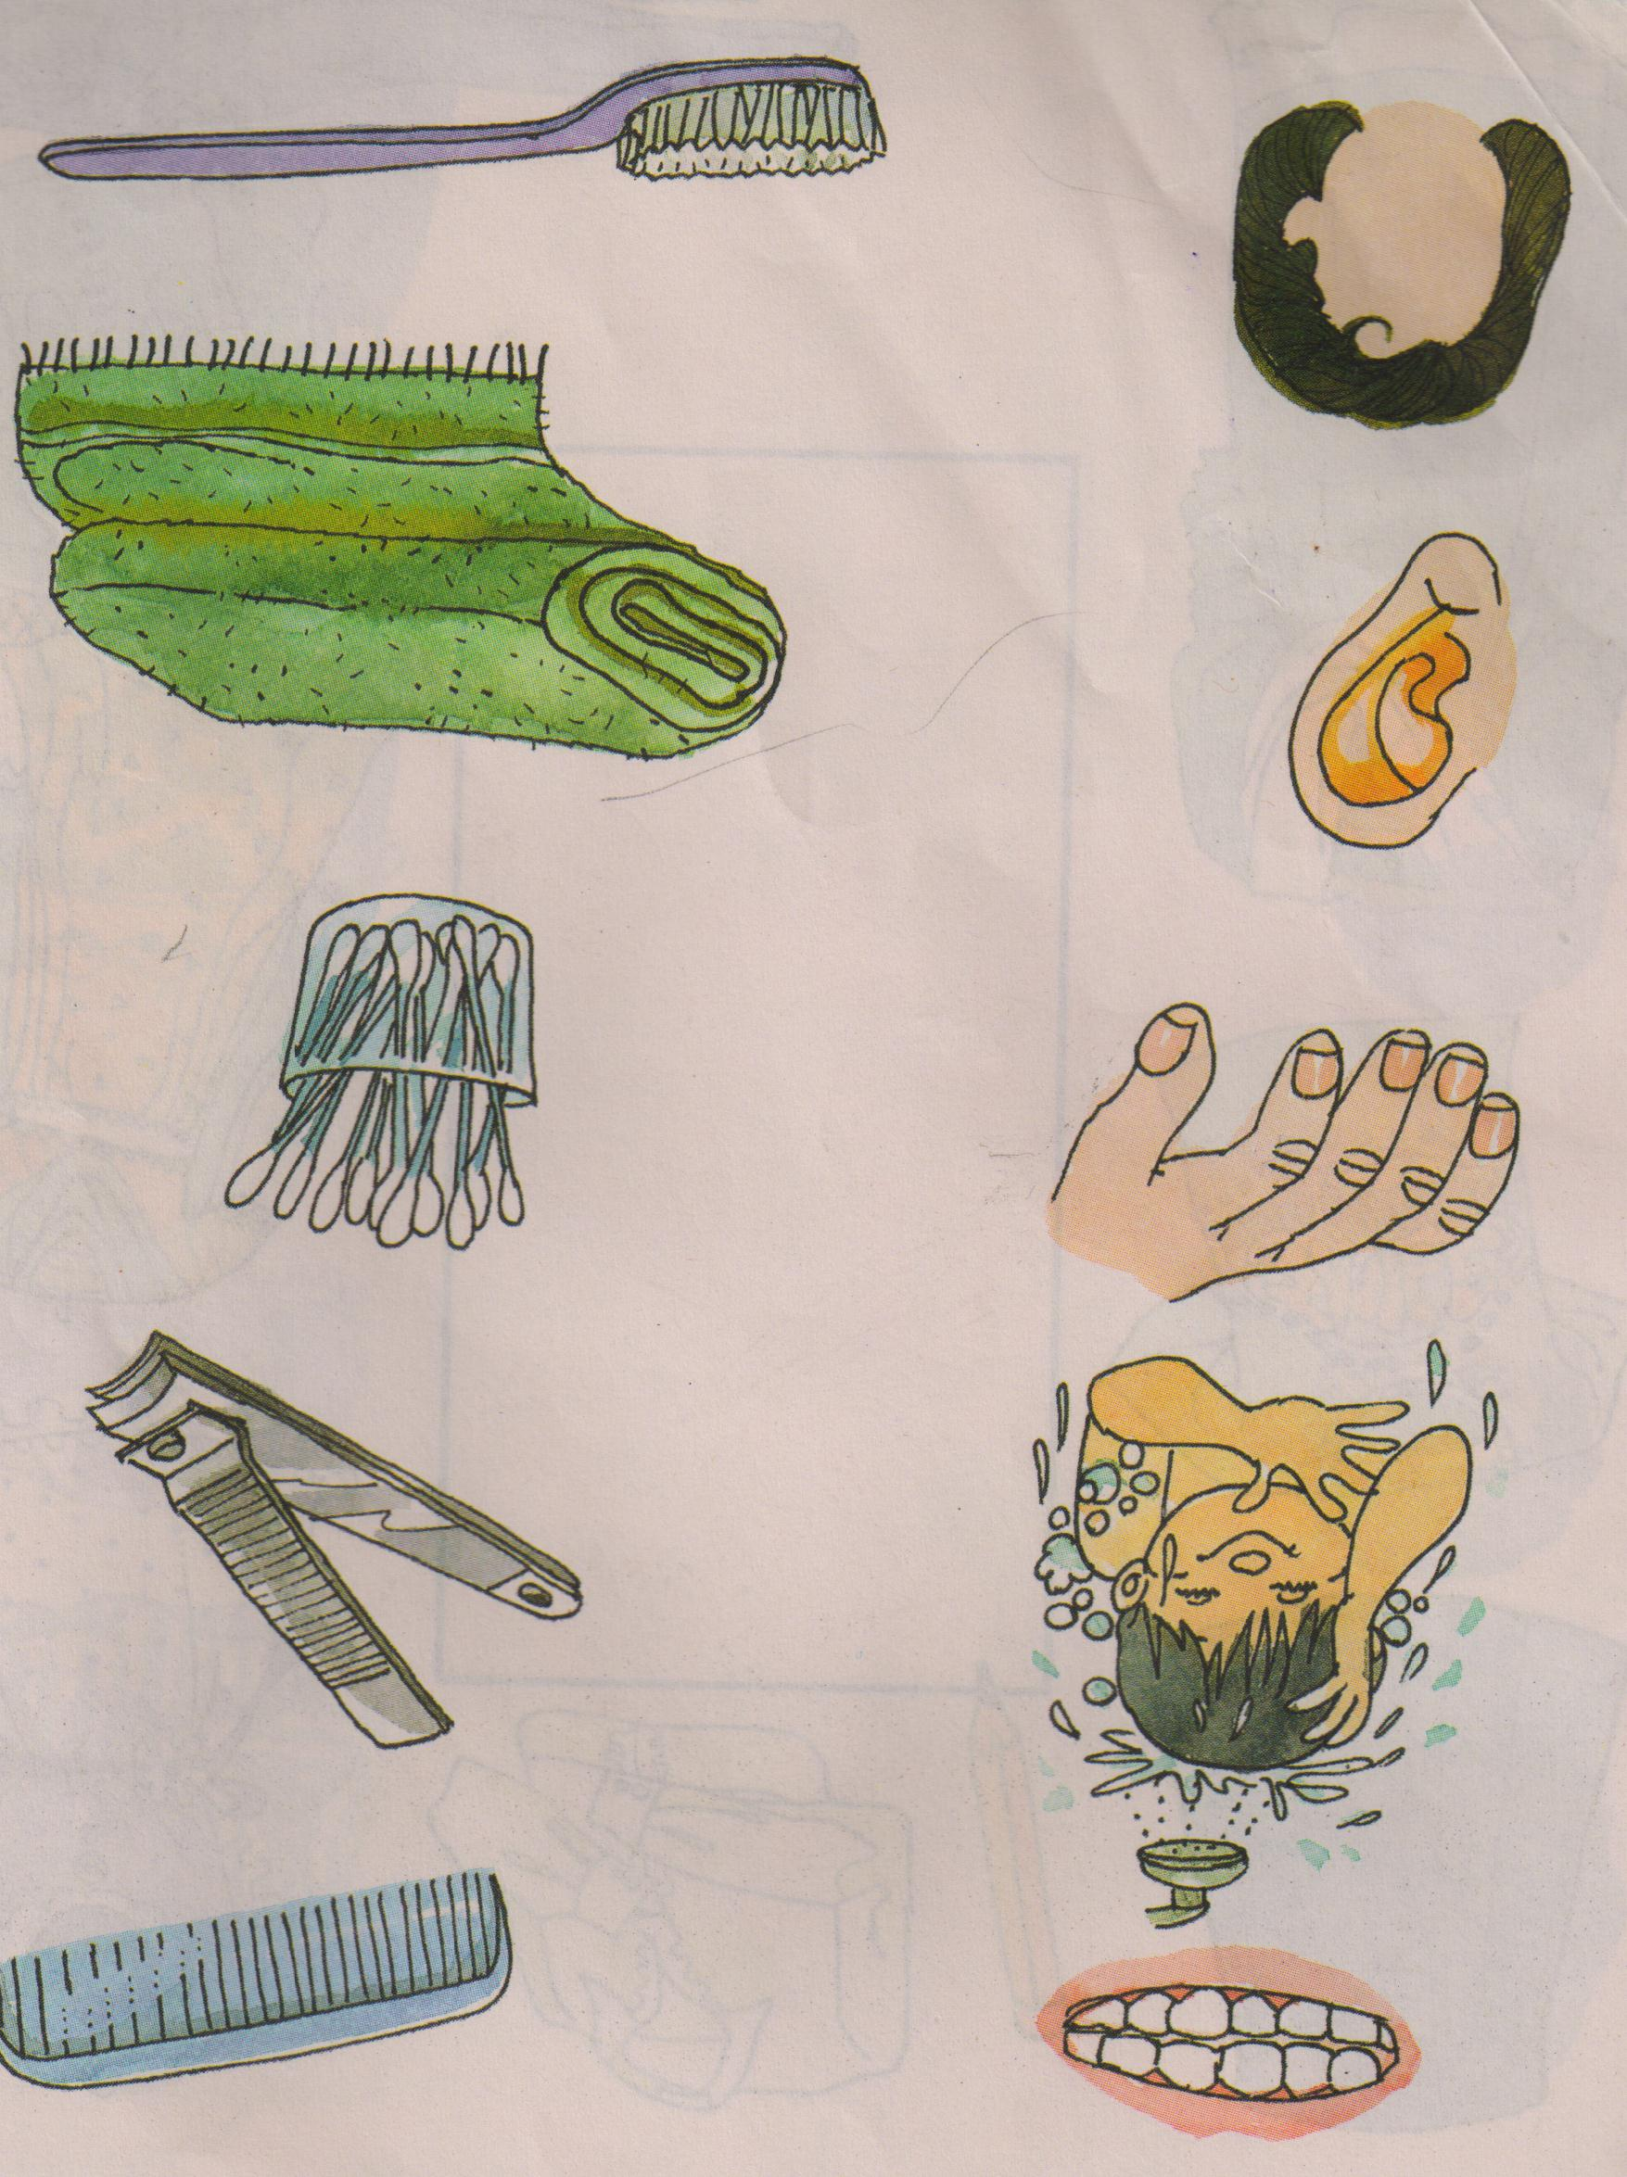
Q1. Match the following.
Q2. This is a picture of a house. Colour the window red, door yellow, roof blue and walls brown.

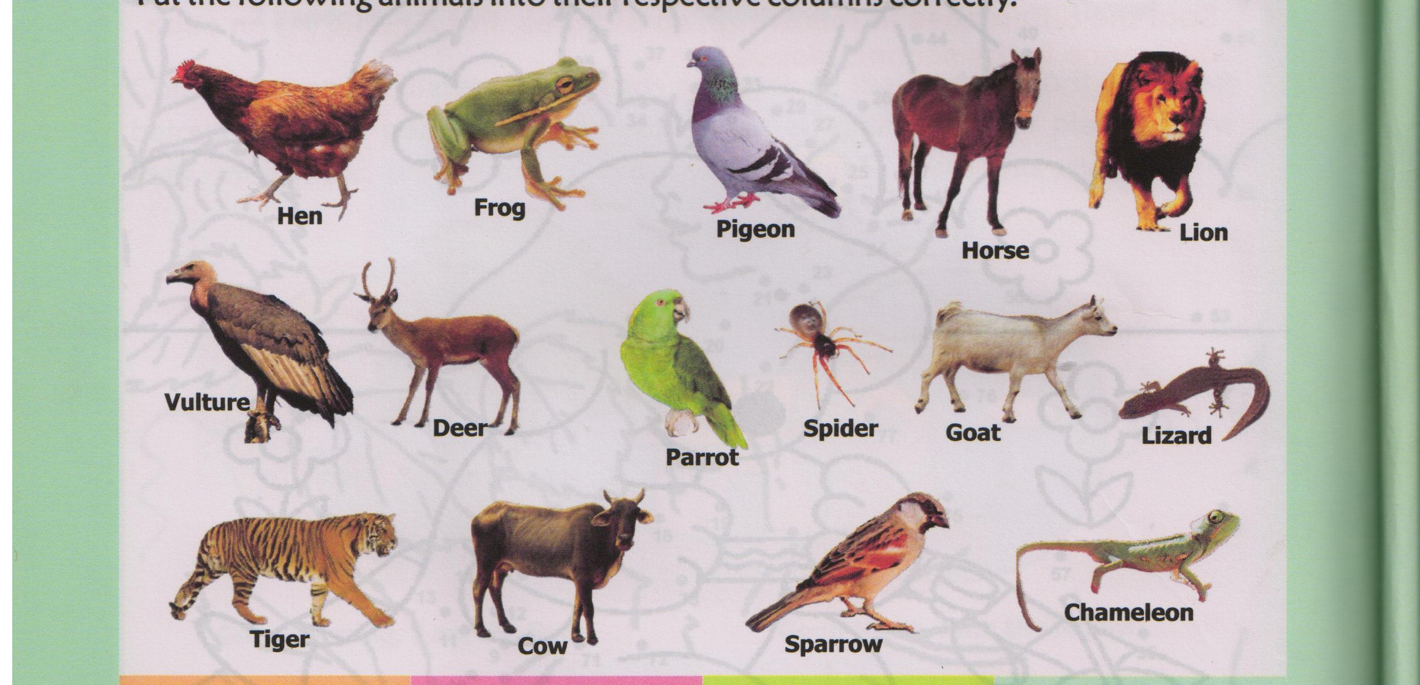
Q3. Encircle the domestic animals.

Q4. Write the name of any five fruits.

a) ________________________

b) ________________________

c) ________________________

d) ________________________

e) ________________________

