DELHI PUBLIC SCHOOL,SRINAGAR
ASSIGNMENT FOR CLASS VI
Social Science (Geography)
MAP WORK
- On the outline political map of the India, mark and label the following states.
- Gujarat ii) Madhya Pradesh iii) Assam iv) Goa

- Kerala vi) Chattisgarh vii) Nagaland viii) Bihar
xi) Jharkhand x) Himachal Pradesh
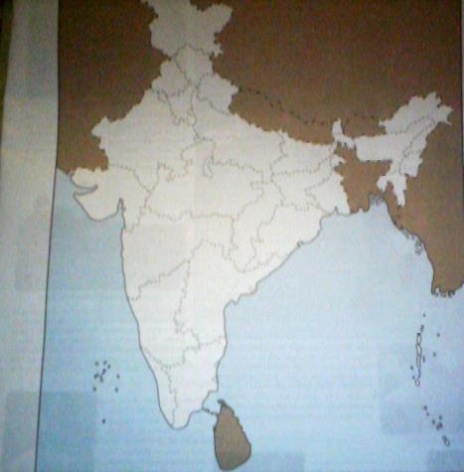
- On the outline physical map of the India, mark and label the following physical divisions.
- Northern Mountains ii) Northern Plains
iii) Great Indian Desert iv) Great Peninsular Plateau
v) Coastal Plains and Islands

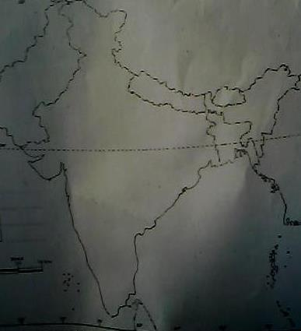
PROJECT WORK:
Choose a state and write about its festival, people and their occupation. Collect pictures. What do you like most about the state?

